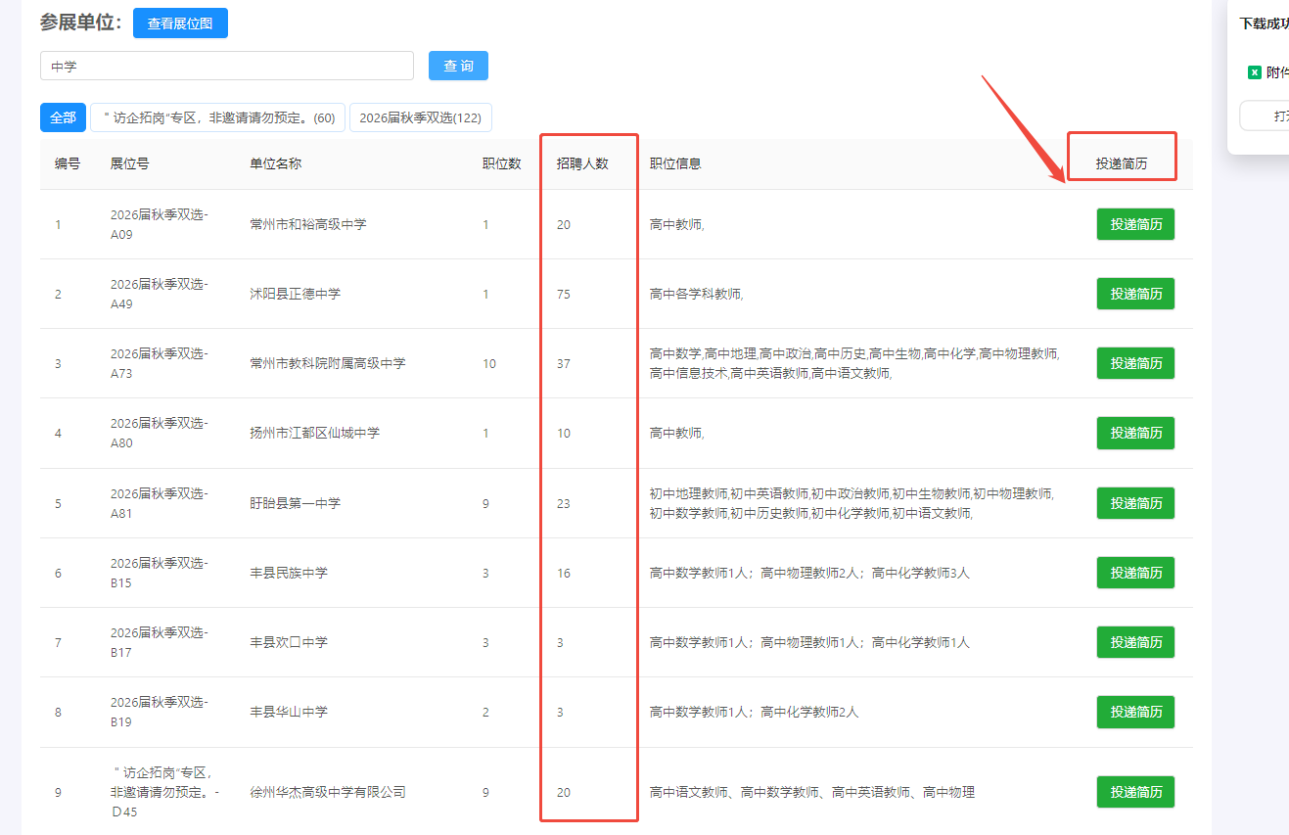

>>浏览器打开链接进入：投递简历

https://www.91job.org.cn/recruitment/meetingDetail?zphid=1000000000076161&xxdm=00000