[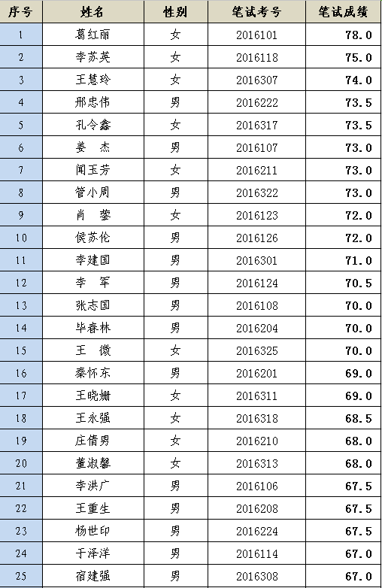](http://www.ljjyw.cn/Item/javascript:;)  
[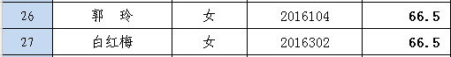](http://www.ljjyw.cn/Item/javascript:;)  
[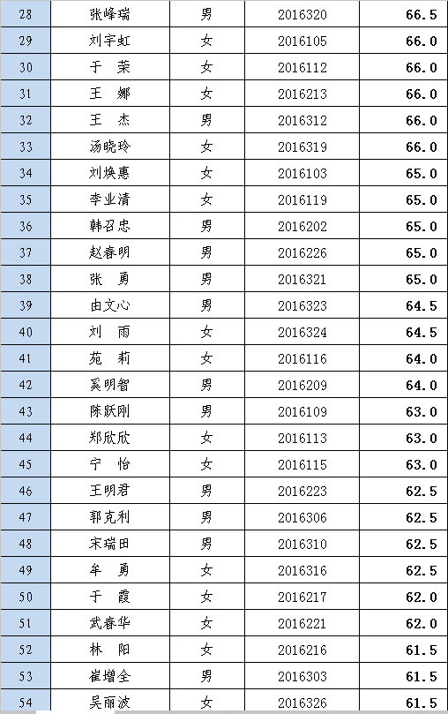](http://www.ljjyw.cn/Item/javascript:;)