招聘岗位及条件

[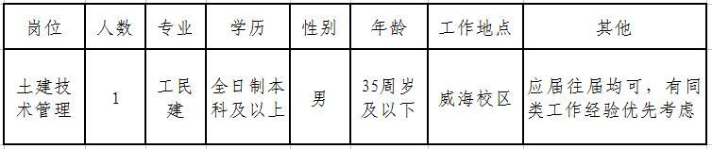](http://rsc.sdjtu.edu.cn/resource/rsc/image/201610/8ea49901-b355-405a-81c8-15b14cc29b2fb.jpg)